I-

II-

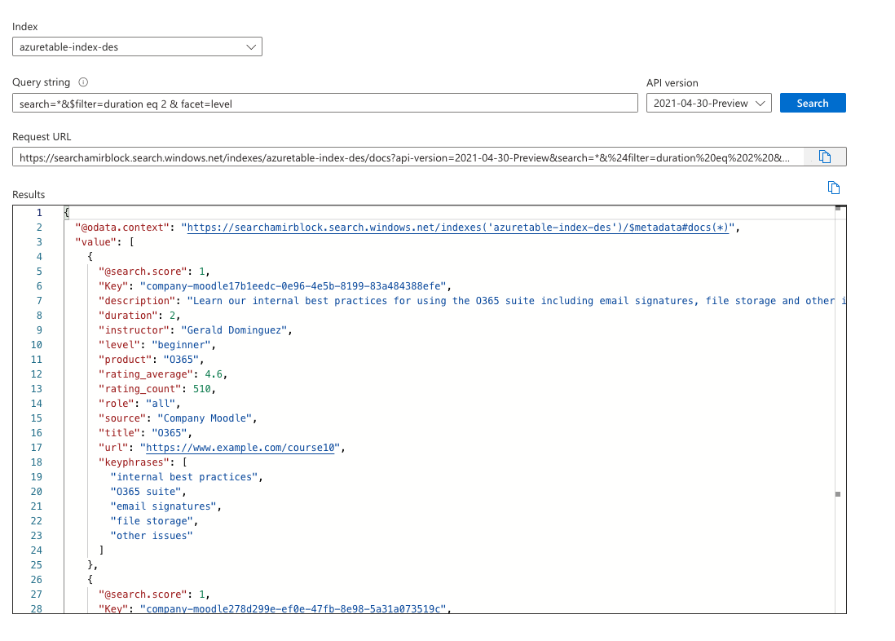

III-

IV-

V-

